Mock Test!
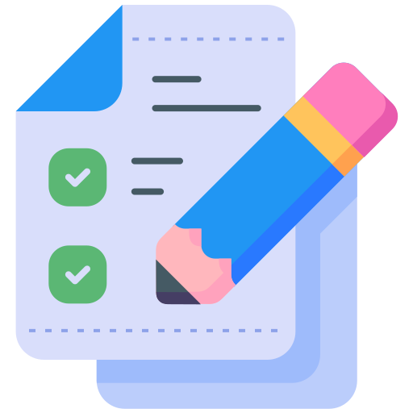

Mock Test for Care: Your Graduation Test! 🎓

Congratulations! You’ve made it to the final stage of your training. This assessment is your golden ticket to graduating and becoming a true StoreHub Merchant Care expert! 🎉

Here’s how it works: Your trainer will step into the shoes of a merchant and chat with you via Live Chat. It’s your time to shine and show off everything you’ve learned over the past few days.

Don’t worry, you’ve got access to all the slides, knowledge base and StoreHub Q—so feel free to use them as your trusty sidekicks during the test! 💡

This isn’t just about knowledge; it’s about combining your soft skills with your product knowledge to deliver a smooth and professional interaction.

Mock Test Condition
Brace yourselves! You're about to embark on a Mock Test Marathon. Here's how it works:

1️⃣ Round 1: Your trainer will take you through the first challenge.
2️⃣ Round 2 & 3: Your coach will join the fun and put your skills to the test.
The goal? Pass all 3 rounds like a pro!

But here’s the twist: If you stumble in any round, it’s back to square one. Yup, you’ll have to restart from Round 1 and work your way up until you conquer all 3 rounds in a row. Think of it as leveling up in a game—only this time, there’s no cheat code!
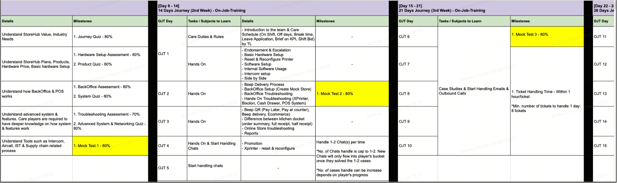
Minimum Requirement: You need to score 80% or higher. If you pass, you’re all set to go and enjoy the fruits of your hard work! 🍎

Scoring Time!
Your Mock Test performance will be assessed using a detailed scorecard—think of it as your very own report card for this mission. Every move you make counts, so bring your A-game!

Good luck, and remember: You’ve got this! 🙌

